Load bitmap file from SD Card

In last exercise "[Save file to SD Card](http://android-er.blogspot.com/2010/07/save-file-to-sd-card.html)", a file have been saved in SD Card. In this exercise, the bitmap file in SD Card will be loaded, using BitmapFactory.  
  
[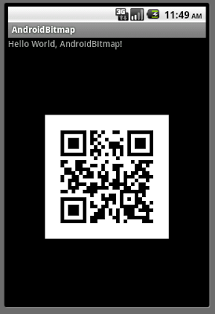](http://1.bp.blogspot.com/_C5a2qH8Y_jk/TD6GlIMYKqI/AAAAAAAAAhU/4zTtkiGNklU/s1600/AndroidBitmap_01.png)  
  
main.xml

<?xml version="1.0" encoding="utf-8"?>  
<LinearLayout xmlns:android="http://schemas.android.com/apk/res/android"  
 android:orientation="vertical"  
 android:layout_width="fill_parent"  
 android:layout_height="fill_parent"  
 >  
<TextView  
 android:layout_width="fill_parent"  
 android:layout_height="wrap_content"  
 android:text="@string/hello"  
 />  
<ImageView  
 android:id="@+id/imageview"  
 android:layout_gravity="center"  
 android:layout_width="fill_parent"  
 android:layout_height="fill_parent"  
 android:scaleType="center"  
 />  
</LinearLayout>

AndroidBitmap.java

package com.exercise.AndroidBitmap;  
  
import android.app.Activity;  
import android.graphics.Bitmap;  
import android.graphics.BitmapFactory;  
import android.os.Bundle;  
import android.widget.ImageView;  
  
public class AndroidBitmap extends Activity {  
  
private final String imageInSD = "/sdcard/er.PNG";  
  
 /** Called when the activity is first created. */  
 @Override  
 public void onCreate(Bundle savedInstanceState) {  
 super.onCreate(savedInstanceState);  
 setContentView(R.layout.main);  
   
 Bitmap bitmap = BitmapFactory.decodeFile(imageInSD);  
 ImageView myImageView = (ImageView)findViewById(R.id.imageview);  
 myImageView.setImageBitmap(bitmap);  
  
 }  
}

[[http://2.bp.blogspot.com/_J90P-hyr9o8/SmR6wLejZpI/AAAAAAAAAbg/iSloE1vTVnE/s200/icons_download.gif](http://www.ziddu.com/download/10716687/AndroidBitmap_files_100715a.zip.html)Download the files](http://www.ziddu.com/download/10716687/AndroidBitmap_files_100715a.zip.html).